MB991
- Subtitles should not be H1. Only main title should be H1.
- 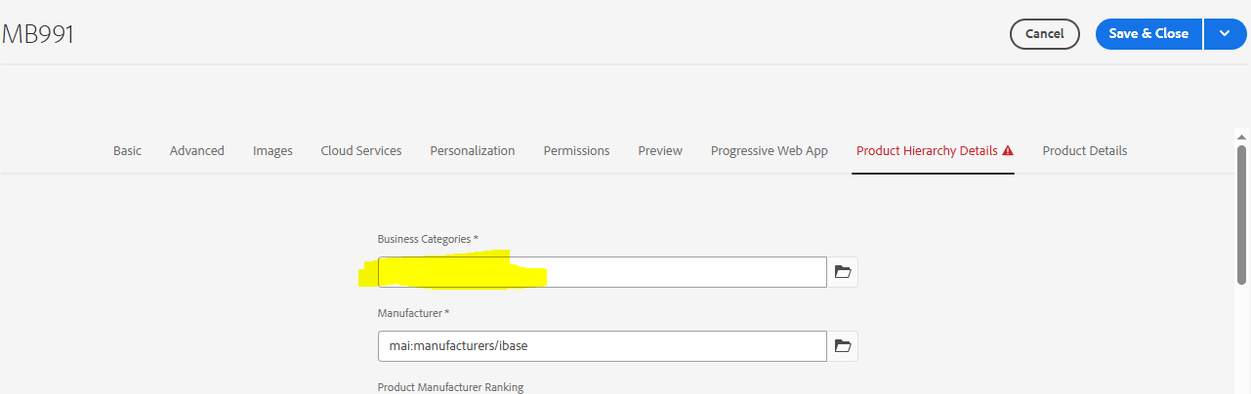
Business categories field should not be empty. It should be Boards and Modules.
- 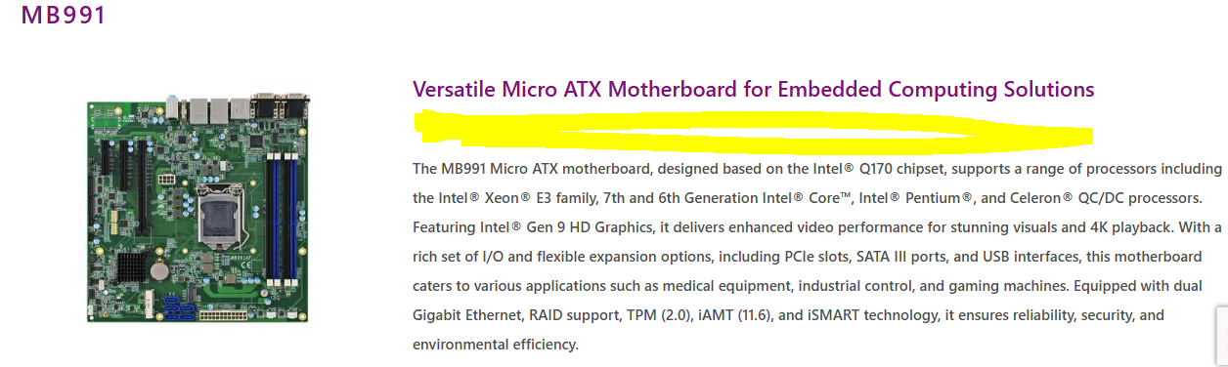
there’s gap between title and description. Press Shift+Enter after Title to avoid space.

4. Helio View Hardware
- 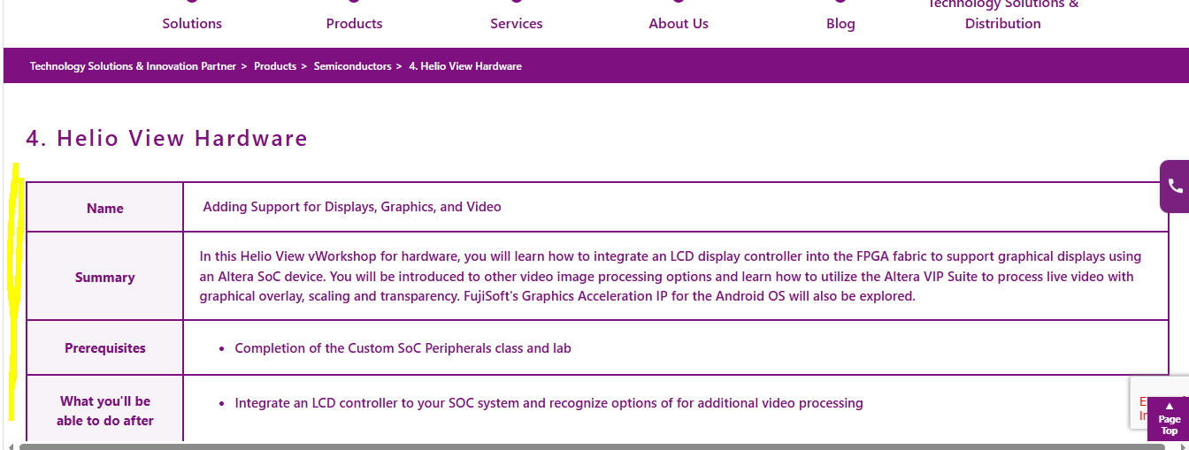
Need to give padding at left/right
8. Helio View Software
- Need to give Padding Left/Right
Need to give Padding Left/Right for all Altera, Anlog, microchip, on-semiconductor, sitime pages
Terms & Conditions
- Spacing b/w section to section
- Fonts are not consistent
Tariff Pass-Through Policy Notification | Macnica Americas
- No need of BG color
- Spaces
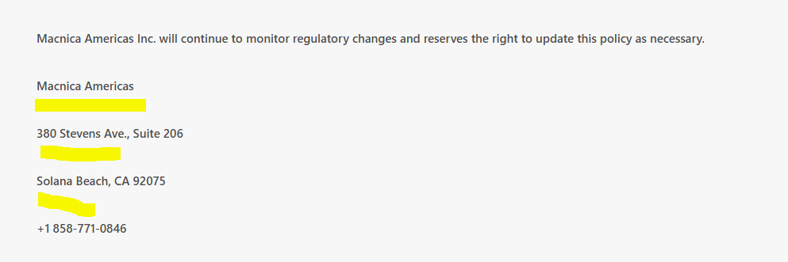
Our Global Solutions Company Office Locations
- Content mismatch
Glossary
- Space b/w tabs and content
- No need of BG color
News archive:
- Tags were missed in al news pages. Like “Year”. “ Article date”
Macnica Announces Production-Ready ME10 SoC for Embedded Devices
- Adjust BG color
- Sub title missing
- Spacing issue
Macnica Americas Adds Toppan ToF Cameras and Modules to Imaging Portfolio
- Sub titles authored at bottom and bottom CTAs are not required
Macnica 100Gbps MEP100 SmartNIC and Partner Innovations on Display Throughout IBC2025
- Sub titles authored at bottom and bottom CTAs are not required
Macnica Accelerates Development of Interoperable SMPTE ST 2110 Solutions for IBC2019
- CTAs at bottom not required
Macnica Technology to Demonstrate SMPTE ST 2110 and NMOS Network Media Switching Solutions at 2019 NAB Show
- Adjust BG color
Macnica Americas Adds TQ Systems to Its Embedded Computing Lineup
- Adjust BG color and CTAs at bottom not required
Macnica to Exhibit at IBC 2018 with ST2110 and NMOS Solutions
- Adjust BG color
Macnica’s ST2110 IP Core Successfully Adopted by Sencore for its New SDI over IP Converter
- Adjust BG color
Macnica Exhibits Its NMOS Solutions and VIPA™-based ST2110 Media End Point at VidTrans18
- Adjust BG color
Macnica Completes Integration of Networked Media Interface Media Transport
- Adjust BG color
Macnica and Tektronix Partner to Ease Broadcasters’ Path to All-IP Operations
- Adjust BG color

